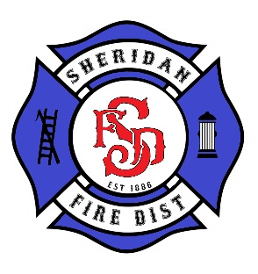
SHERIDAN FIRE DISTRICT
Board of Directors
May 16, 2023, at 6:30 p.m.
Sheridan Fire District Main Station
230 SW Mill Street
Sheridan, OR 97378

AGENDA
ZOOM: https://us02web.zoom.us/j/85137889230

● Meeting called to order by the Board President

● Flag Salute

● Roll Call

● Budget Work Session

● Adjournment

